Assignment 3b Report

Anoop Revanth
2015CS10265 2015CS10219

Broadcast Algortihm 1

Section 1.a

For K > 64, there has been no significant improvement in the time taken for broadcast.
This is because some devices come into contact with very few devices. Once these devices have missed the broadcast, the chance for them to get it is very less. So even for large values of K, transferring the broadcast to such devices is difficult. (Start Node = 26)
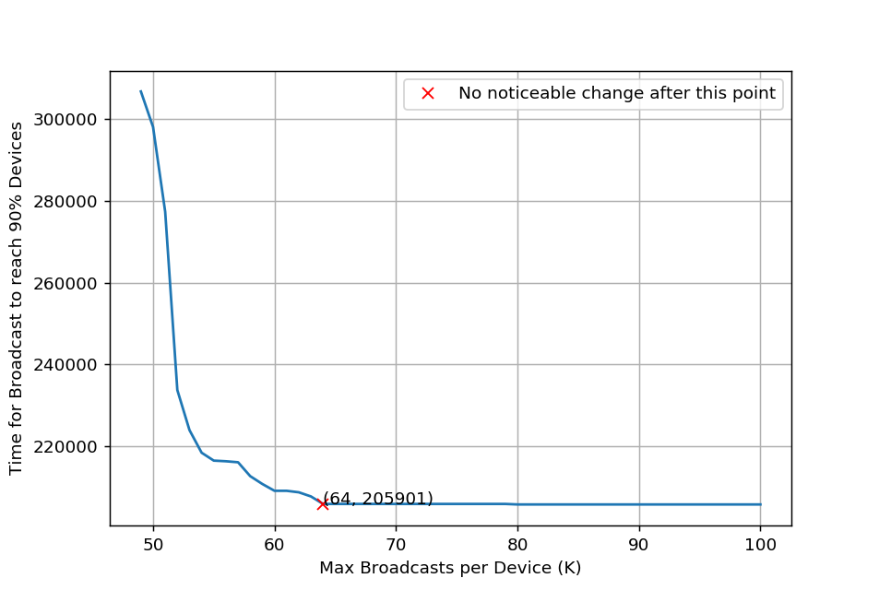

Section 1.b

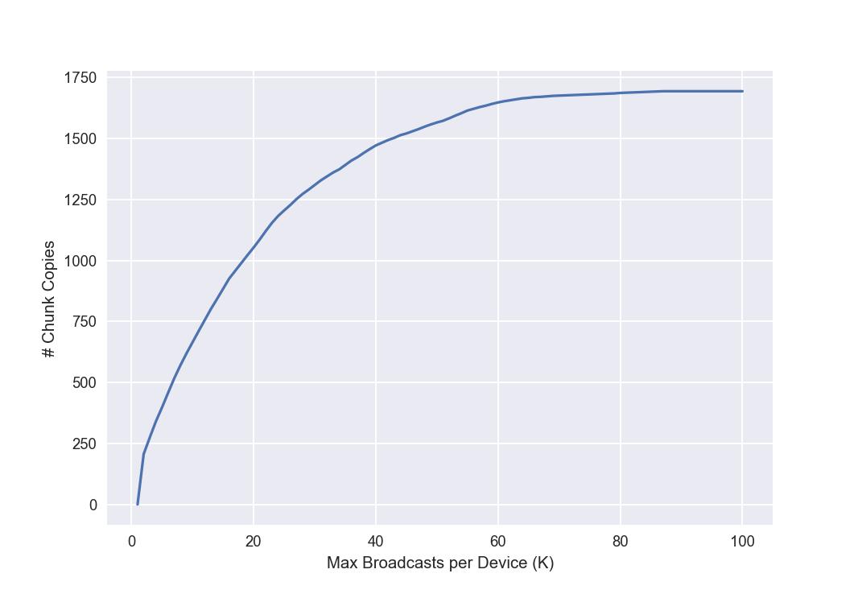

Section 1.c
The trends observed with 100 random sources is not same as that with source = 26.
Reason - There are some devices which come into frequent contact with other devices and some which rarely come in contact with other devices. So when these devices are chosen as source, the reachability is less, which pulls down the mean.
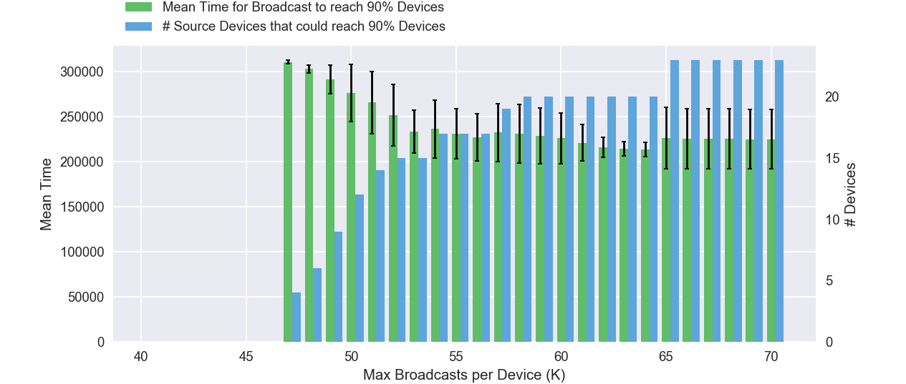

CCDF Plot

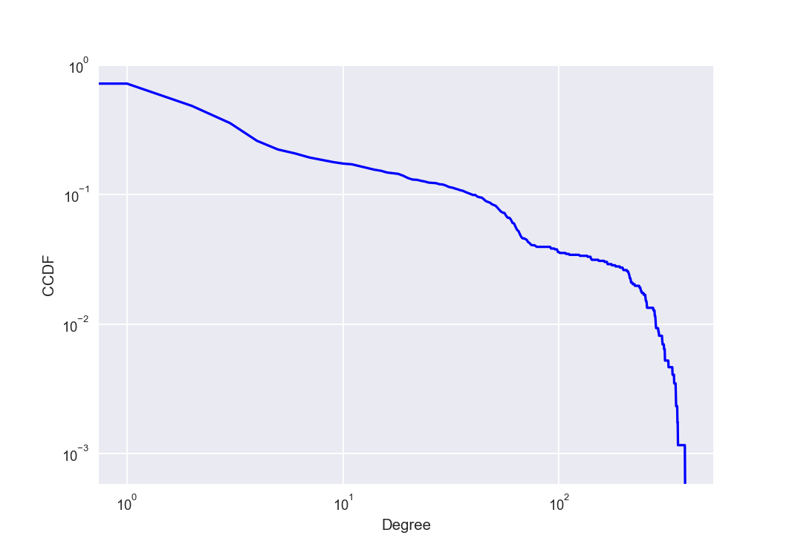

Broadcast Algortihm 2

Section 2.a

Best Combination - x = 2-10%, y = 80-90% (with S = 0.5%, L =70% and Start Node = 26)
This combination has reached 90% devices quickly as well as reduced the load on Super-Nodes and Ordinary-Nodes.
The load on Super-Nodes and other nodes is incomparable. Super-nodes have to transmit a lot more than other nodes.
Giving Super-Nodes higher probabilty to receive the chunk guarantees that the broadcast is reached quickly to all devices but puts more load on the Super-Nodes. This is the tradeoff between Load on Super-Nodes and Broadcast Time.

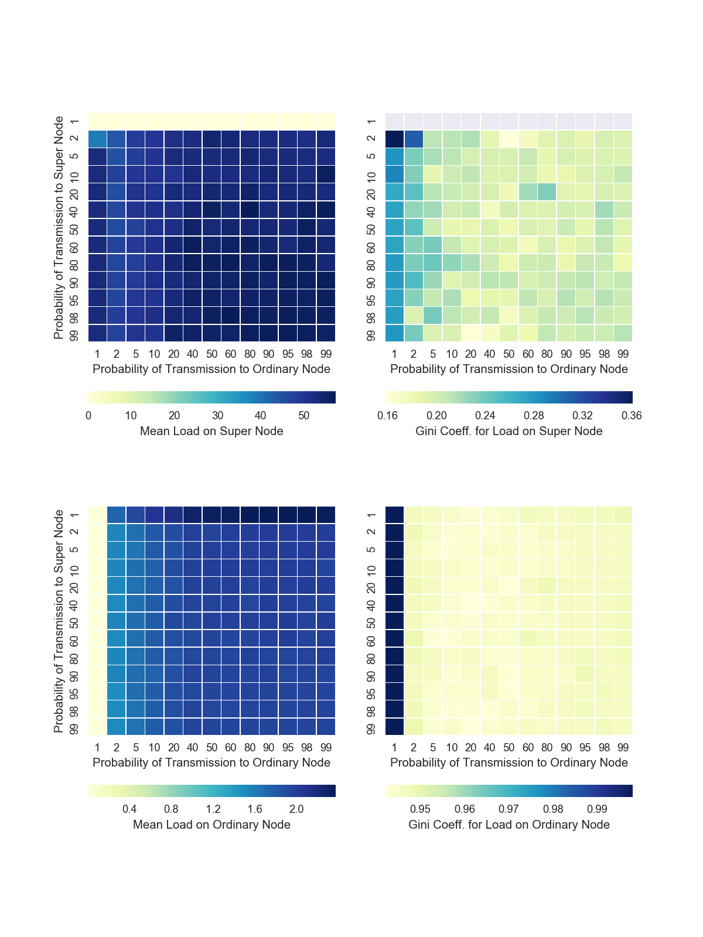

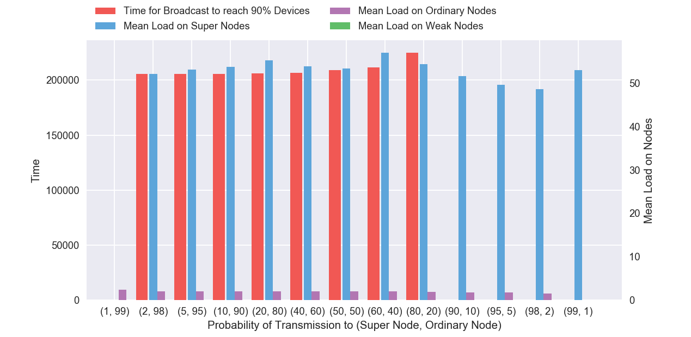

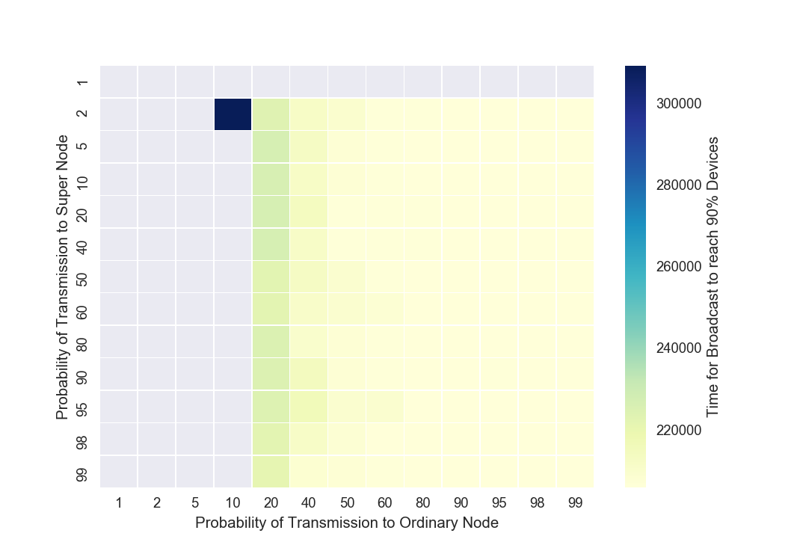

Section 2.b

The distribution of loads to nodes nad the time taken for broadcast to reach 90% of the nodes obtained on repeating the experiment with 100 random devices is mostly similar to the one where starting device is considered to be 26. There are few exeptions in the boundary cases like when Probabilty of Transmission to Super-Node is 1. The best combination found with starting device 26, is reasonably good when we consider the distribution with 100 random devices.
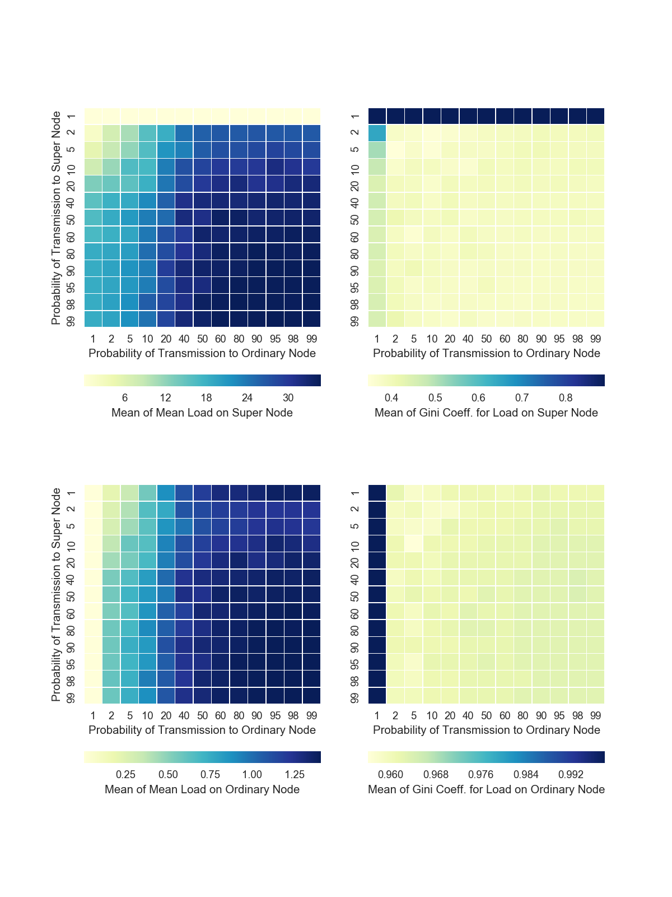
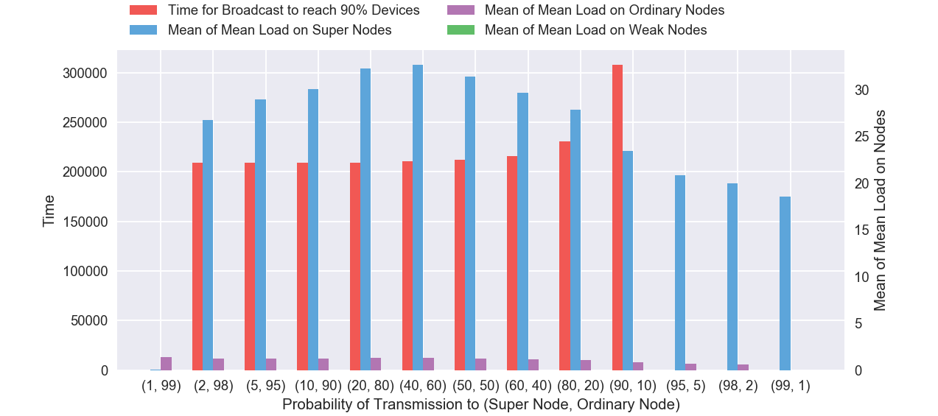

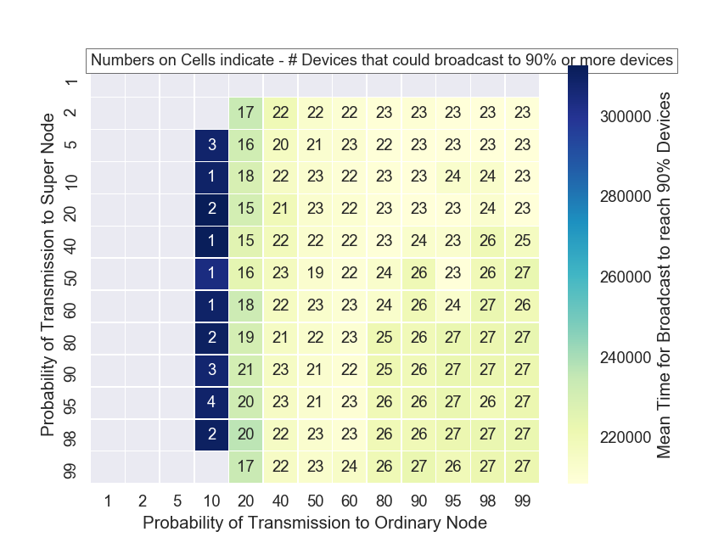
Section 2.c

As S increases from 1-30% (with L = 70%), the best value of Probability of Transmission to Super Node increases. More number of devices being considered as Super-Nodes implies for better transmission of broadcast, the probability of transmitting the broadcast to Super-Nodes must be more. (Start Node = 26)

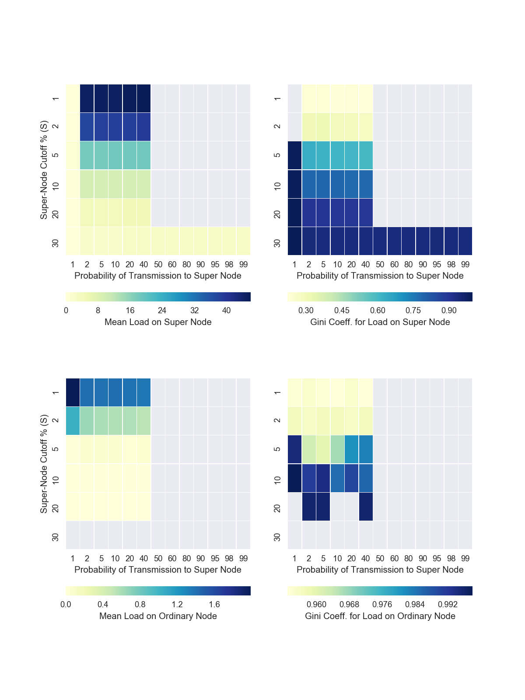

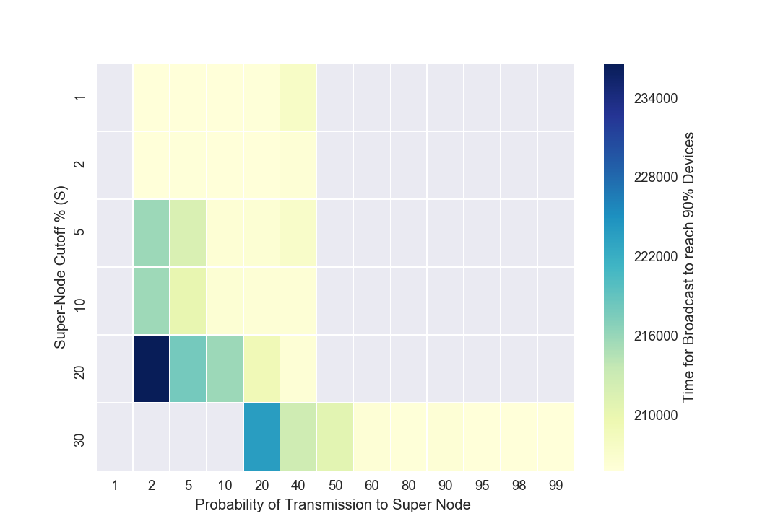

Section 2.d

As L varies from 1-99% (with S = 0.5%), there is not much change in the best value for Probability of Transmission to Super-Node. This is due to the fact that L does not cause any changes to number of Super-Nodes. As L increases, the load on Super-Nodes increases slightly and load on Ordinary-Nodes increases greatly. (Start Node = 26)
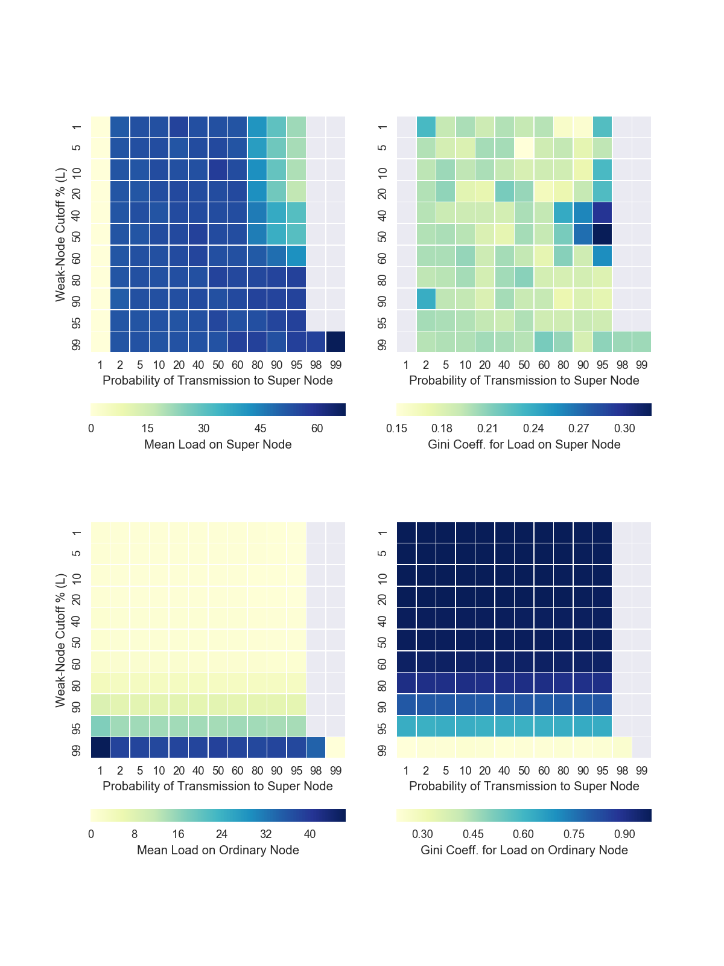

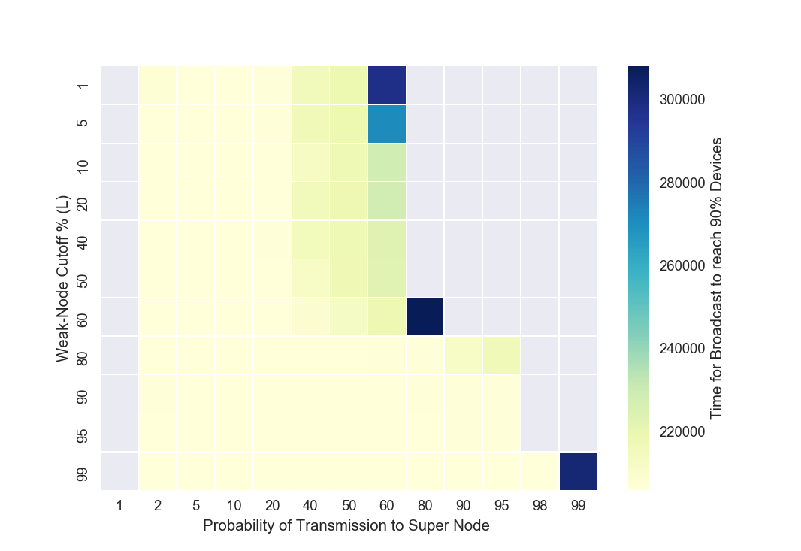

Broadcast Algortihm 3

Best Combination – X = 60-70% and Y = 90-95% (Start Node = 26)
This combination ensures best transimission time and also reduces load on all nodes.
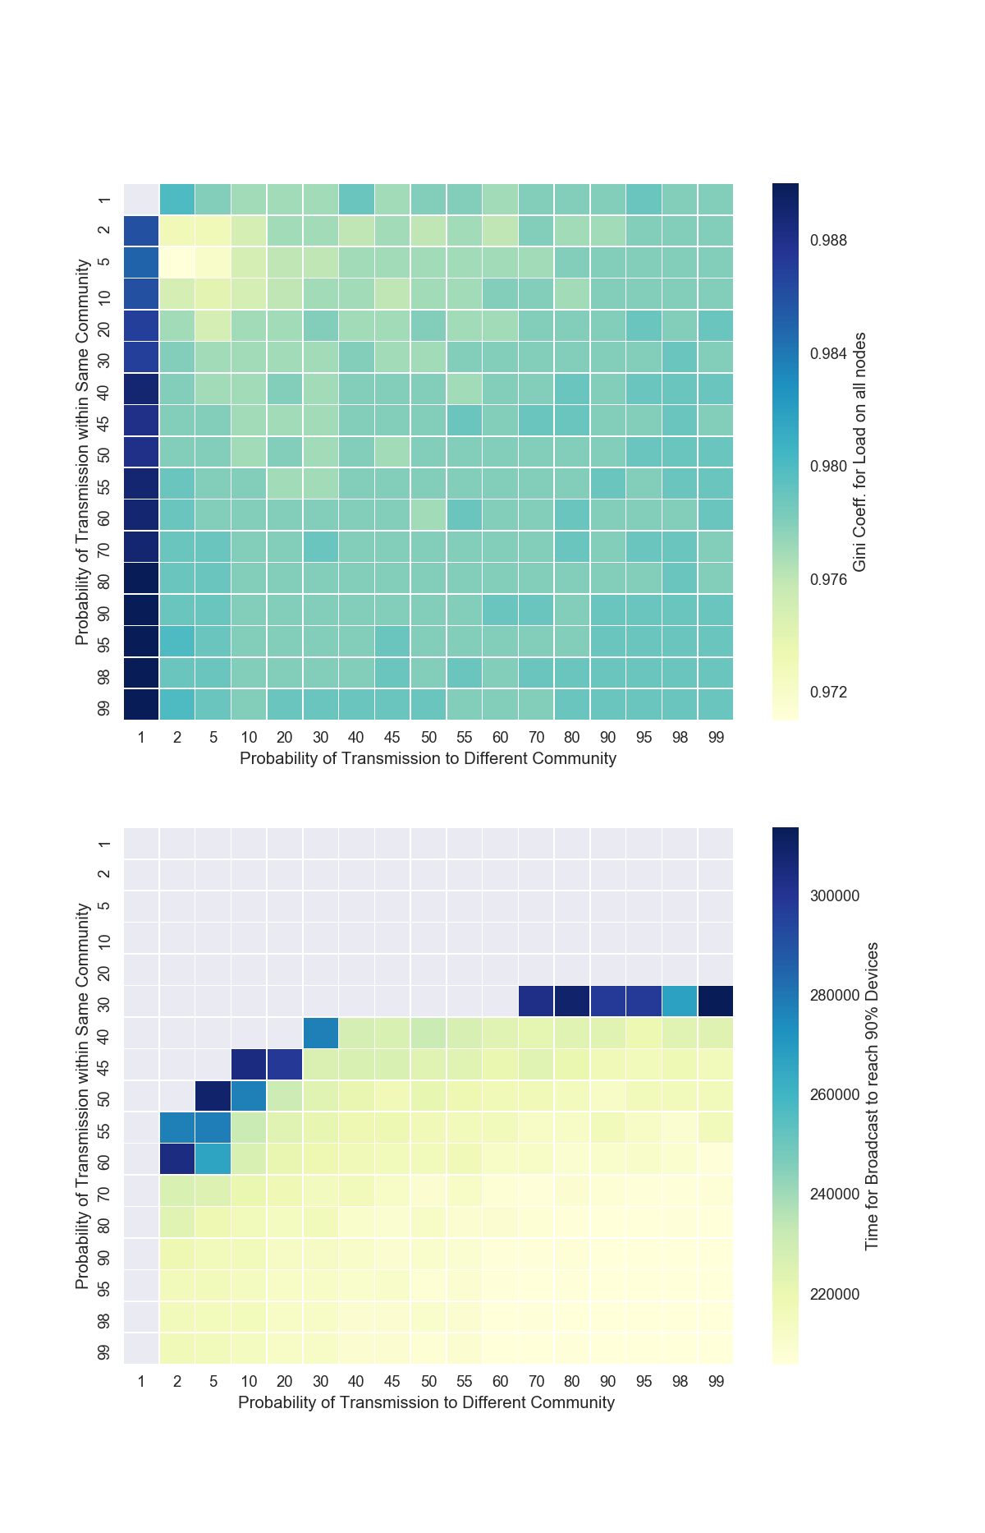

With 100 random starting devices, the distribution of load and transmission time is similar to that with starting node as 26.

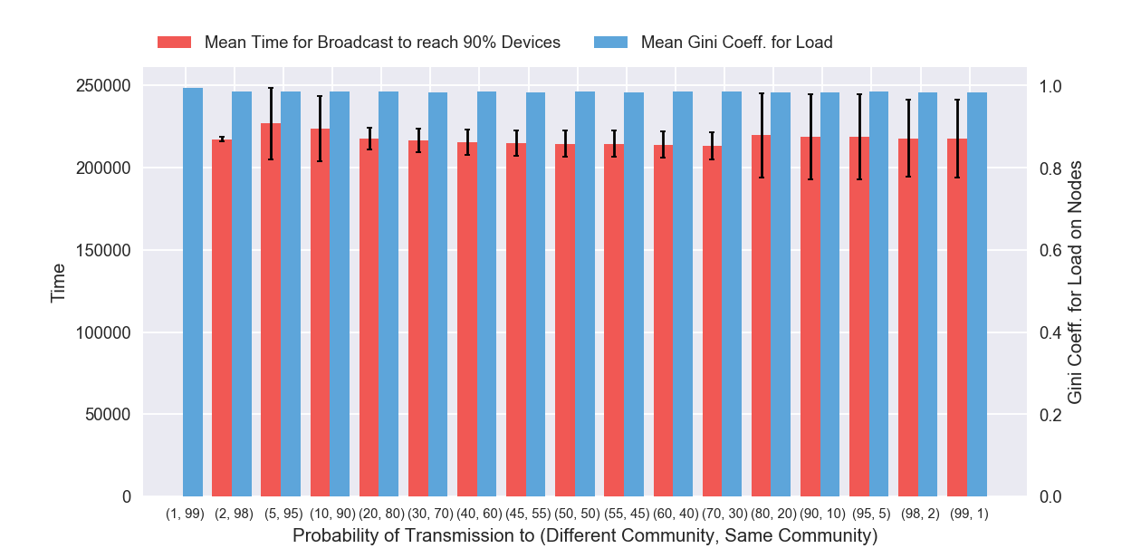

Analysis of Broadcast Algorithms implemented

- In the first algorithm, there is cap on number of broadcasts made by a device.
- In the second algorithm, devices are classified into three classes (Super/Ordinary/Weak) based on how frequently they come into contact with the network.
- In the third algorithm, devices are clustered into communities based on their proximity.

Reachability – For some parameters of the algorithms, all the three achieve good reachability.
Time for broadcast – All the three algorithms complete the broadcast in roughly same time (min.).
Load on Nodes – Second algorithm prioritizes load on nodes best. Though first algorithm tries to cap the number of broadcasts, this does not ensure that load is distributed well.
Effective Transmission – Third algorithm ensures that message from one cluster reaches another cluster which can be overlooked in the second algorithm. It also ensures proper load distribution among nodes.

